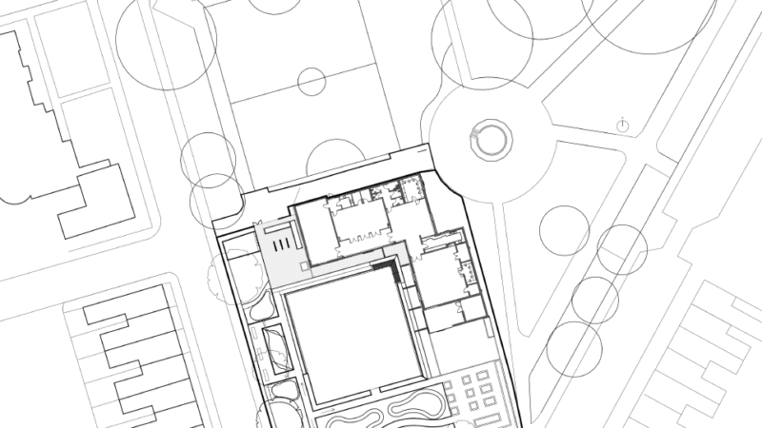

Take a look at our initial plans…
You can see here the original landscape plans as we set out to redevelop the grounds of the 1962 bowls pavilion in Grange Gardens, and to create a biodiverse, environmentally rich and sustainable outdoor space for use and enjoyment by the community and that is maintained by the community.
Co-produced landscaped proposals included:
- surface drainage rain gardens and ponds
- an outdoor classroom and planters for school and community use
- an orchard
- a ‘Welsh Manuka’ pollinator garden developed with Cardiff University pharmacists
- enhanced biodiversity for improved air, soil, water and noise quality in an industrially polluted landscape
- a green for community activities.
We've seen how activities on site have developed from these initial plans. You can find out about current activities on our events page.

